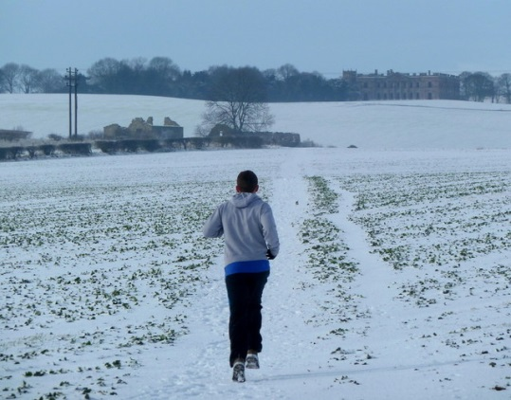
Training Details
- 18 Week Training Program
- Training begins the week of Oct 19th (first few weeks schedule posted on front page of website)
- FIRST MEETING – Wed Oct 21st
- Session Finishes – Sun Feb 21st
- There will be 2 Training Groups BASED on MEETING times: morning and evening with all abilities welcome
  - evening meets Wed @ 5:30 pm and Sat @ 7:30 am
  - morning meets Wed @ 6:30 am and Sat @ 7:30 am
- Train with other Boulder Strider Members at your goal pace in a non-intimidating atmosphere
Boulder Striders’ Program Rates
Discounted Rates for ALL | $350  $325 | twice/week - 18 weeks of twice a week training  once/week – 18 weeks of once a week training  (please make payment by October 24th)
Online Price  (thru Oct 24th) | $175 | Follow the 18 week program without joining group training  (for those that want to train with us…but do it alone)
MAKE CHECKS PAYABLE TO: BOULDER STRIDERS
OR CREDIT CARD...ADD $12 TO THE PROGRAM RATE
OR Venmo…@Darren-DeReuck
Please Print & Mail Registration to:
Boulder Striders, 4162 Saint Croix St, Boulder, CO 80301 OR Bring to Training from Oct 21st-24th
2020-21 Fall/Winter Registration Form
Last Name |  |  |  |  | First Name
Address
City |  |  |  | State |  |  |  |  |  | Zip
DOB |  |  | Email
Day Phone
 | Evening: Wed/Sat (5:30 pm /7:30 am ) |  |  |  |  |  | Morning: Wed/Sat (6:30 am / 7:30 am )

By signing this Registration Form, I do not hold Colleen De Reuck, Boulder Striders or any of the Coaches liable for injury to myself during the 18 week training. One Form per Member…Photocopies are good.

Signature: __________________________________________

